Dijkstra's Algorithm
Dijkstra's Algorithm allows you to calculate the shortest path between one node (you pick which one) and every other node in the graph. You'll find a description of the algorithm at the end of this page, but, let's study the algorithm with an explained example! Let's calculate the shortest path between node C and the other nodes in our graph:
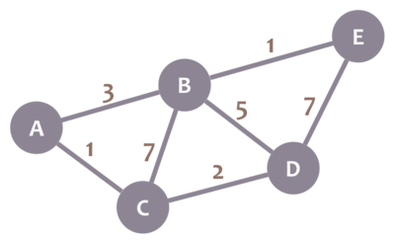
During the algorithm execution, we'll mark every node with its minimum distance to node C (our selected node). For node C, this distance is 0. For the rest of nodes, as we still don't know that minimum distance, it starts being infinity (∞):
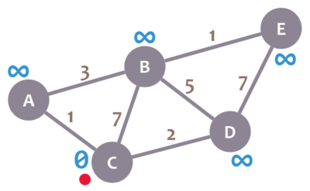
We'll also have a current node. Initially, we set it to C (our selected node). In the image, we mark the current node with a red dot.
Now, we check the neighbours of our current node (A, B and D) in no specific order. Let's begin with B. We add the minimum distance of the current node (in this case, 0) with the weight of the edge that connects our current node with B (in this case, 7), and we obtain 0 + 7 = 7. We compare that value with the minimum distance of B (infinity); the lowest value is the one that remains as the minimum distance of B (in this case, 7 is less than infinity):
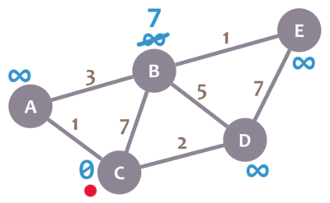
So far, so good. Now, let's check neighbour A. We add 0 (the minimum distance of C, our current node) with 1 (the weight of the edge connecting our current node with A) to obtain 1. We compare that 1 with the minimum distance of A (infinity), and leave the smallest value:
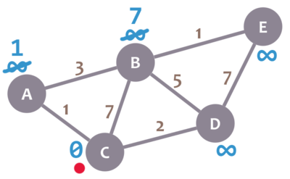
OK. Repeat the same procedure for D:
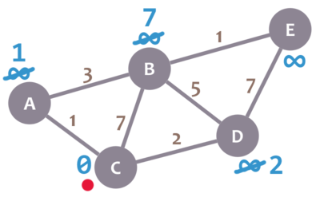
Great. We have checked all the neighbours of C. Because of that, we mark it as visited. Let's represent visited nodes with a green check mark:
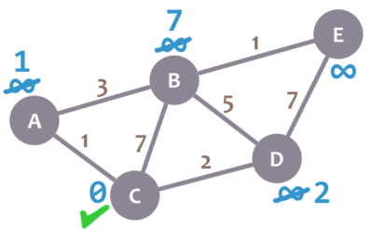
We now need to pick a new current node. That node must be the unvisited node with the smallest minimum distance (so, the node with the smallest number and no check mark). That's A. Let's mark it with the red dot:
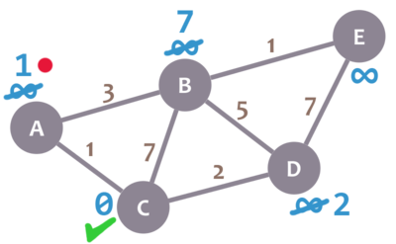
And now we repeat the algorithm. We check the neighbours of our current node, ignoring the visited nodes. This means we only check B.
For B, we add 1 (the minimum distance of A, our current node) with 3 (the weight of the edge connecting A and B) to obtain 4. We compare that 4 with the minimum distance of B (7) and leave the smallest value: 4.
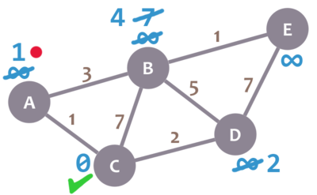
Afterwards, we mark A as visited and pick a new current node: D, which is the non-visited node with the smallest current distance.
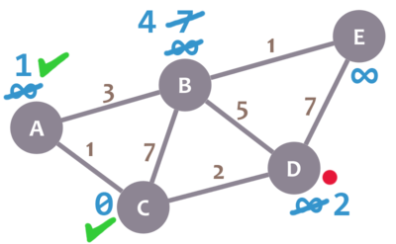
We repeat the algorithm again. This time, we check B and E.
For B, we obtain 2 + 5 = 7. We compare that value with B's minimum distance (4) and leave the smallest value (4). For E, we obtain 2 + 7 = 9, compare it with the minimum distance of E (infinity) and leave the smallest one (9).
We mark D as visited and set our current node to B.
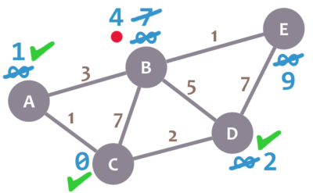
Almost there. We only need to check E. 4 + 1 = 5, which is less than E's minimum distance (9), so we leave the 5. Then, we mark B as visited and set E as the current node.
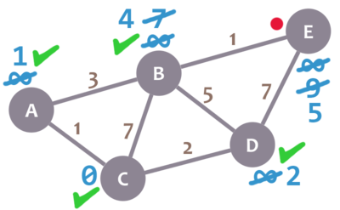
E doesn't have any non-visited neighbours, so we don't need to check anything. We mark it as visited.
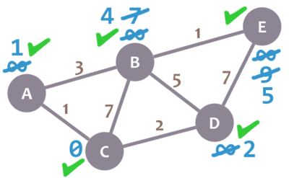
As there are not univisited nodes, we're done! The minimum distance of each node now actually represents the minimum distance from that node to node C (the node we picked as our initial node)!
Here's a description of the algorithm:
- Mark your selected initial node with a current distance of 0 and the rest with infinity.
- Set the non-visited node with the smallest current distance as the current node C.
- For each neighbour N of your current node C: add the current distance of C with the weight of the edge connecting C-N. If it's smaller than the current distance of N, set it as the new current distance of N.
- Mark the current node C as visited.
- If there are non-visited nodes, go to step 2.

Calculating paths, too
Let's run the algorithm again in our graph:

This time, however, let's keep track of the actual shortest paths. They all begin empty, except for the path of the initial node, which simply contains it:
path to A = empty
path to B = empty
path to C = C
path to D = empty
path to E = empty
The new thing is that we will update those paths every time we modify the minimum distance of a node.
Let's check the neighbours of our current node. Let's begin with B. We add 0 + 7 = 7. As that value is less than infinity, we change the minimum distance of B with it and replace the current path to B with the path to the current node (path to C, which is C), plus B. This means that path to B = C, B.
We repeat the procedure with neighbours A and D. After that, our graph and paths are as follows:

path to A = C, A
path to B = C, B
path to C = C
path to D = C, D
path to E = empty
Our current node is now set to A. We check its only non-visited neighbour, B. As we replace the minimum distance of B from 7 to 4, we also replace its current path with the path of the current node A (C, A), plus B: path to B = C, A, B).

path to A = C, A
path to B = C, A, B
path to C = C
path to D = C, D
path to E = empty
We mark A as visited and select our next current node: D. We check two neighbours: B and E.
When checking B, we don't replace its minimum distance (as the existing 4 is less than the calculated 7), so we don't replace its current path, either. Remember: we only replace a path when we modify the minimum distance of a node.
We then check neighbour E, update its minimum distance (9, which is less than infinity) and path (path to E = C, D, E, which is the path to D plus E), and are left with this:

path to A = C, A
path to B = C, A, B
path to C = C
path to D = C, D
path to E = C, D, E
Let's fast-forward a bit: we continue applying the algorithm until we're done. After we finish, our graph and paths will be the following:

path to A = C, A
path to B = C, A, B
path to C = C
path to D = C, D
path to E = C, A, B, E
Congratulations! Those are the minimum paths between C and every other node!
Here's Dijkstra's Algorithm again:
- Mark your selected initial node with a current distance of 0 and the rest with infinity.
- Set the non-visited node with the smallest current distance as the current node C.
- For each neighbour N of your current node C: add the current distance of C with the weight of the edge connecting C-N. If it's smaller than the current distance of N, set it as the new current distance of N.
- Mark the current node C as visited.
- If there are non-visited nodes, go to step 2.
Let's see some small enhancements we may apply to the algorithm:
- If you only need the path between two specific nodes, you can stop the algorithm as soon as you mark your second node as visited.
- Sometimes, there are several minimum paths between two nodes (different paths with the same weights). If you wish, you can keep track of all those variants: in step 3, if there is a tie between the calculated value and the current distance, save both the old current path and the new one. This complicates the tracking, but it may be useful to you.
- If you finish the algorithm because there are not univisted nodes left but there are nodes which minimum distance is still infinity, those nodes don't have any valid path to the original node.

